Minutes  Minutes AAUBS Council  Thursday 30. november 2023  09.30-11.30, Fib 2, room 35 | Aalborg University Business School  Fibigerstræde 2  9200 Aalborg Ø

Members: Klik eller tryk her for at skrive deltagere/faste medlemmer. Mette Vinter Larsen (formand), Jesper Sort (VIP), Jonas Eduardsen (VIP), Michael Simonsen (TAP), Victor Bach Petersen (ESA)
Cancellations: Jacob Rubæk Holm (VIP), Mikael Randrup Byrialsen (VIP), Mikkel Christian Rosengreen (ØF), Lasse Steen Jensen (TAP)

Observers: Christian Østergaard, Holger Roschk, Gunnar Rimmel, Dmitrij Slepniov
Cancellations: Finn Olesen, Michael Dahl, Jacob Brix, Frederik Lundtofte
Guest: Mie Bech
Moderator: Victor Bach Petersen

Agenda
- Approval of Agenda
- Approval of Minutes
- Update from the Head of Business School
- Presentation of next year budget and plan for open positions (stillingsplan) (årshjul)
- Discussion of AAUBS organization in the interim period
- Follow-up on Business School Conference / AAUBS Day on November 14th, 2023 (årshjul)
- Discussion of report Universities for the future: Twenty years of the University Act by The Danish Council for Research and Innovation Policy
- Discussion of Ph.d. program management
- Self-evaluation: Evaluating the Council’s work in the past year (årshjul)
- Approval of meeting schedule for next year (årshjul)
- Update from Student representatives and Research Groups
- Communication from the meeting
- AOB

1. Approval of Agenda
Explanation: Approval of the agenda for the meeting
Notes: The agenda was approved by the Council.
Follow up:

2. Approval of Minutes
Appendix: Minutes from AAUBS Council meeting on September 18th, 2023
Explanation: Approval of minutes from AAUBS Council meeting on September 18th, 2023
Notes: Minutes of meeting on September 18th, 2023, was approved by the Council.
Follow up:

3. Update from the head of Business school
Appendix: Action plan for diversity and inclusion (in Danish)
Appendix: Viden for Verden” målaftale 2024 (in Danish)
Explanation: Mette will give an update on:
- Budget and new positions for 2024 was approved on November 22nd, 2023. See also item 4 on the agenda.

- Qualified employment freeze has been terminated from November 22nd, 2023.

- Business Advisory Council meeting on November 20th, 2023. The management met with BAC to discuss four central
aspects: How to ensure quality in our core tasks, act in responsible ways and balance being a business school embedded in the region and internationally relevant. Furthermore, we discussed possibilities and pitfalls regarding the possible candidate reform.
The overall feedback was that they find the topics relevant and interesting. They encourage us to reach more out to the region as many of the regional players want to be involved in both teaching and research and would like to collaborate with students. Regarding the Candidate reform they encouraged us to initiate a process where we benchmark ourselves up against the 10 most relevant business schools, invite students and organizations into this process as relevant stakeholders.

- Action plan for diversity and inclusion discussed with the Council in the meeting on September 18th, 2023, and
handed in to the faculty on October 10th, 2023. The action plan has recently been approved by FSU and the faculty management and outlines one activity for diversity and one activity for inclusion aimed at reducing language barriers for international employees at AAUBS.

Based on input from the Council and SAMiU, the diversity activity focuses on how Danish and English can be used equally as working languages and chosen based on what is most appropriate in each situation. We will set focus on upgrading of language proficiency for employees at AAUBS in relation to both Danish and English language.

The inclusion activity focuses on the on-boarding process which we are currently reviewing to ensure that new employees receive a comprehensive introduction to AAUBS and work areas.

The action plan for diversity and inclusion is attached and serves as basis for upcoming discussions in the Council regarding the use of Danish and English as working languages, as well as onboarding.

- SSH-agreement “Viden for Verden” målaftale 2024 discussed with the Council in the meeting on September 18th, 2023
and handed in to the faculty on October 20th, 2023. The plan has received feedback from the SSH Dean and the Rector’s office and will be finally approved medio December 2023. The “Viden for Verden” målaftale 2024 is attached and includes the six prioritized goals, described with specific activities for 2024 at the institute level.

- Research evaluation and the appointment of the fourth (and final) member of the evaluation panel. The
fourth member is Martin Holmén (Professor, Gothenburg University/Department of Economics,) who will be involved with the MAMTEP, Acc. and Finance research groups.
The other members of the panel are:
- Per-Olof Brehmer (Professor, Linköping University / Department of Management and Engineering, Sweden). Per
also participated in the evaluation panel in 2018. Relevant research groups: Marketing, SOM, IB.
- Gry Agnete Alsos (Professor of Innovation & entrepreneurship, Nord University Business School, Bodø, Norway),
Relevant research groups: IKE, SOM, IB.
- Thomas Carrington (Professor, Faculty of Social Sciences, Business and Economics, and Law, School of Business
and Economics, Åbo Academie University, Finland). Relevant research groups: Acc, Finance, (MAMTEP)

- AAU elections taking place on November 27th – 30th, 2023. Do remember to vote. For the academic staff we have
three approved candidates (for four available seats) and for the technical/administrative staff we have one approved candidate (for two available seats). This means that we are lacking two candidates for the new AAUBS Council to be constituted as of February 1st, 2024.
We are responsible for finding the last two candidates ourselves, so please reach out to colleagues and have them contact Mette Vinther Larsen, if they are interested in being appointed candidate for the Council.
Notes: The Council took note of the update and welcomes the termination of the qualified employment freeze as well as activities on the action plan for diversity and inclusion.

It was decided that going forward “Update from the head of Business school” will only be discussed in the meeting if members have questions.
Follow up: Potential candidates for the new AAUBS Council must contact Mette Vinther Larsen a.s.a.p. ​ ​
4. Presentation of next year budget and plan for open positions (stillingsplan) (årshjul)
Appendix
Explanation: Mie Bech will present the budget for 2024 as well as plan for open positions (stillingsplan) for 2024, including budget assumptions and parameters expected to impact the 2024 budget.
The budget for 2024 was finally approved by the dean on November 22nd, 2023.
Mie Bech presented the budget for 2024, which is expected to be balanced by the end of 2024 as well as adding five new positions to the plan for open positions (stillingsplan) for 2024. The five new positions have not been determined yet and there is no guarantee that temporary positions will be refilled.

The budget includes the following points of attention that were discussed with the Council:
- The budget 2024 is based on a conservative budgeting in agreement with the dean, which the Council
supports.
- Included in the budget is an increase in revenue on educations until 2026 due to a rise in tariff, along
with a projected decrease in student intake, especially in 2026. The key to maintaining the budget largely depends on minimizing the decline in student intake and ensuring that students complete the study programs. Therefore, the students’ well-being and marketing of the study programs to set up a high-profile AAUBS brand to guide the youths (international students, students from other AAU-faculties and universities) will be central over the next years.
Simultaneously, the research grant is budgeted to increase, while external turnover is expected to decrease due to a decline in revenue from external activities. Together with the deanery we have focus on the increasing AAU-contribution which is set to rise from DKK 58,461 to DKK 68,337 by 2026. In general, we pay a relatively high contribution to AAU, so we have to get better at utilizing shared facilities, systems, and services, among others.
- A budgeted decrease in administrative/TAP expenses due to the elimination of certain operational -and
salary costs for EVU and communication, as well as removal of expenses for external consultants.
- Reduction in travel -and conference costs for the management team, as well as a smaller management
team,
- A reserved budget for the research groups for research activities,
- A budgeted decrease in staff costs in relation to Full time Studies due to a significant reduction in censor
ship resources.

The Council took note of the information on the budget 2024 and open position plan (stillingsplan), happy to learn that the budget is in better balance than announced primo 2023.
Follow up: Mie Bech will present the budget at the budget 2024-2026 meeting on December 7th, 2023, for all employees to attend.

5. Discussion of AAUBS organization in the interim period
Appendix

Explanation: Mette would like to discuss ideas and considerations regarding the new organization of the Administration and the introduction of staff managers for VIP from 1st January 2024.

Notes: Mette Vinther Larsen initiated the discussion of the AAUBS organization in the interim period by presenting proposals for a new structure for staff managers and suggestions for reorganization of the administration.
For the staff manager role, the following three proposals are to be considered. The staff manager role is to be divided between half-time academia work and half-time staff responsibility. The staff manager will be affiliated with a research group rather than specific job titles as previously, in close collaboration with the research group leader.
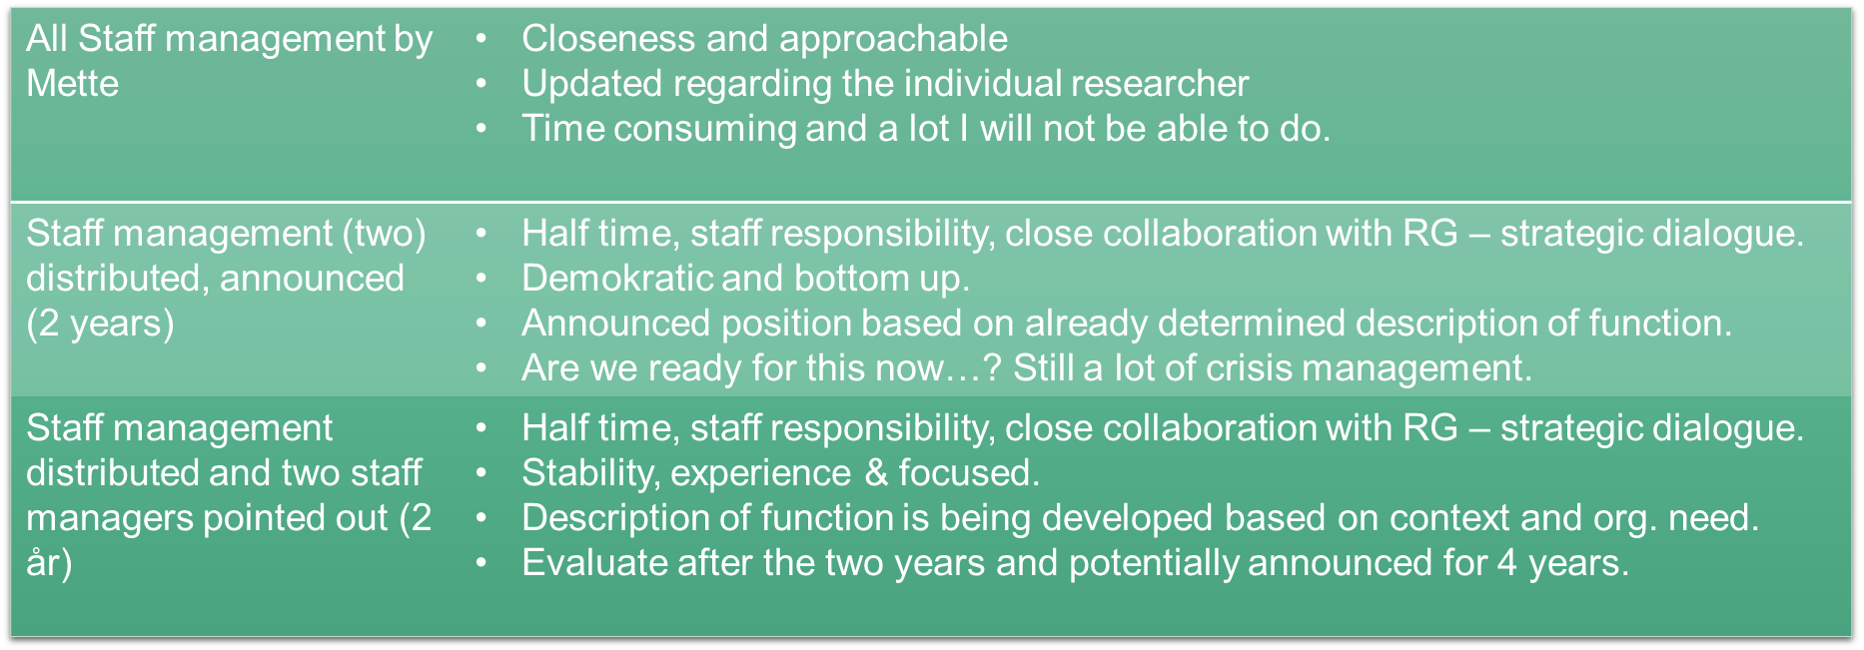
For the administration, a reorganization of the administration into the following administrative units is considered: HR, Full time study administration, Projects & Funding (including Ph.D. administration), and Quality Assurance & Data Management (see the figure below), in order to boost activities on funding, projects, as well as data collection, processes, and analyses. The model presented is an initial draft for the future administration at AAUBS and will be discussed with the administrative staff at coming meetings. The administrative staff will be involved in defining their future task portfolio going forward. It will be open for everyone in the administration to change “seat” if they would like.
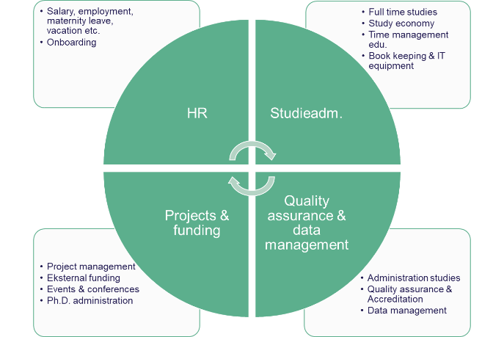

The Council welcomes the proposal for a new organization within staff management and administration with the following comments:
- The Council emphasizes the need for stability in the organization with focus on staff manager role as a
part-time position with close reference to academia and the research groups. The staff manager should be appointed for two years as a start. Mette Vinther Larsen informed during the meeting that regardless of the chosen model, it has been agreed with Dean Rasmus Antoft that the chosen model extends beyond the interim period, which the Council supports.
- The Council supports the idea that Mette Vinther Larsen takes on the staff manager role for the "new" research groups and research group leaders.
- The Council emphasizes the need for a job description to be written for all VIP-functions (teaching and research staff) and the administrative staff to make it clear to everyone “who does what”.
Follow up: Based on input from the Council, Mette Vinther Larsen will follow up on the staff manager model. In this context, Mette Vinther Larsen will take on the staff manager role for the "new" research groups and appoint two other experienced staff managers to handle the staff manager role for the remaining research groups.

Additionally, Mie Bech, Helle Pia Kramer and Mette Bærentsen will continue the dialogue with the administrative staff regarding the future task portfolio for each of the employees.
They will also initiate discussions with the research groups on the administrative support for the research groups going forward.

6. Follow-up on Business School Conference / AAUBS Day on November 14th, 2023 (årshjul)

Appendix: Input from November 14th, 2023
Explanation: The AAUBS Day was held on November 14th, 2023, as an internal seminar focusing on “people and core tasks” with discussions on how quality and cooperation between VIP and TAP can be integrated in our core tasks. Furthermore, how we can ensure we realize these core tasks in responsible ways.
Mette has gone through all the input and will discuss the ideas for ensuring that the inputs are being anchored in the overall AAUBS strategy and culture at the workplace. The first initiative has already been rolled out – the Friday greeting where colleagues’ small stories about why AAUBS is a special place are being sent out and shared as reminders of what we want to stand for.
Furthermore, ideas about what the next AAUBS day should focus on are welcome and will be discussed.
Notes: Not addressed in the meeting.
Follow up:
7. Discussion of report Universities for the future: Twenty years of the University Act by The Danish Council for Research and Innovation Policy
Appendix (available in Danish and English): Report “Universities for the future: Twenty years of the University Act” / “Universiteter for fremtiden: Tyve år med universitetsloven”
Appendix: PowerPoint presentation of the report (in Danish)
Explanation: The Council has been asked by Rector’s office to discuss the report “Universities for the future: Twenty years of the University Act” by the Danish Council for Research and Innovation Policy in an AAU context by focusing on the following two questions:
- How can we ensure research freedom at AAU?
- How can we ensure employee involvement and a democratic culture at AAU?
They are asking for input from the Council on the questions in bullet points or short sentences and send to Rector’s office no later than December 15th, 2023.
Notes: Not addressed in the meeting. The Council decided to address the discussion in a written consultation, instead.
Follow up: Members must send input to the questions to Malene Kjerulf Christensen, mkc@business.aau.dk no later than December 11th, 2023, in the morning. Input will be gathered and send to Rector’s office.
8. Discussion of Ph.D. program management

Appendix: Process of extending the enrollment of Ph.D. students
Appendix: Seminars for progress
Explanation: Discussion of thoughts on the function of the Ph.D. programme leader and joint AAUBS Ph.D. progress seminars by Poul Houman Andersen, focusing on:
- Considerations related to developing and reorganizing the bi-annual evaluations
- Considerations related to the process of extending the enrollment of Ph.D. students
Notes: Not addressed in the meeting. The Council will have a discussion of the Ph.D. program management in the next council meeting.
Follow up:

9. Self-evaluation: Evaluating the Council’s work in the past year (årshjul)
Explanation: Self-evaluation is new on the agenda aimed at assessing the work of the Council and highlighting positive experiences, maintaining effective practices, as well as discussing and modifying aspects that are less successful. It is determined that the evaluation will take place annually without formal requirements regarding the evaluation process.
It is recommended that the Council in the self-evaluation discusses current meeting structure -and management, including material for the meeting, as well as topics for discussion in the meetings in relation to ensure the right set-up for discussions and decision-making.
Notes: For the self-evaluation, the Council expressed satisfaction with the work in the Council and the meeting setup; head of business school as overall responsible for the agenda and meeting material. It was decided to continue the pre-meetings between the head of business school and moderators for discussion of draft agenda.
The common goal for members of the Council and the management in the coming year is to become better at prioritizing items on the agenda to ensure sufficient time for discussion and decision-making in the meetings, including more time available for “Update”.
Follow up:
10. Approval of meeting schedule for next year (årshjul)
Explanation: The AAUBS Council is to decide on the meeting schedule in 2024. We propose the following dates in 2024 for the AAUBS Council meetings:
- March 4th, 2024,
- May 27th ,2024,
- September 23rd, 2024,
- November 25th, 2024

Notes: The Council decided on the dates proposed for 2024.
Follow up: Malene Kjerulf Christensen will send out calendar-invites for the meetings in 2024.
11. Update from Student representatives and Research Groups
Explanation: Short round table update.
- The student representatives would like to ask the Council for advice on initiatives for building bridges between the AAUBS-staff and students and introducing the interim management to the students.
Notes: Victor Bach Petersen (student representative) is asking the Council to consider initiatives for building bridges between the AAUBS-staff and students in the coming period. Initiatives could be AAUBS staff attending student events, an annual event for AAUBS staff and students on research, students to assist in research projects e.g.
The Council is suggesting setting up a collaboration between the AAUBS staff and student organisations to organize events and activities as mentioned above.
Follow up:

12. Communication from the meeting
Explanation: What do we need to communicate from the meeting?
Notes: The Council decided on the following communication from the meeting:
Mie Bech will present the budget at the budget meeting on December 7th, 2023, for all employees to attend.

Mie Bech, Helle Pia Kramer and Mette Bærentsen will continue the dialogue with the administrative staff regarding future task portfolio.

Follow up:

13. AOB
Explanation:
Follow up: Not addressed in the meeting.

