Minutes  Minutes AAUBS Council  Monday 15. maj 2023  09.30-11.30, Fib 2, 117 | Aalborg University Business School  Fibigerstræde 2  9200 Aalborg Ø

Members: Klik eller tryk her for at skrive deltagere/faste medlemmer. Christian Nielsen (formand), Jacob Rubæk Holm (VIP), Jesper Sort (VIP), Mikael Randrup Byrialsen (VIP), Jonas Eduardsen (VIP), Michael Simonsen (TAP), Lasse Steen Jensen (TAP), Victor Bach Petersen (ESA)
Cancellations: Mikkel Christian Rosengreen (ØF)

Observers: Frederik Lundtofte, Lorenzo Massa, Holger Roschk, Gunnar Rimmel, Dmitrij Slepniov
Cancellations: Finn Olesen, Michael Dahl, Svetla Marinova, Christian Østergaard
Moderator: Jonas Eduardsen & Michael Simonsen

Agenda
- Approval of Agenda
- Approval of Minutes
- Update from the Head of Business School
- Follow-up on Business School Seminar (årshjul)
- Follow-up on budget and plan for open positions (årshjul)
- Presentation of setup for the accreditation work
- INSIGHTS
- Update from Students representatives and Research Groups
- Communication from the meeting
- AOB

1. Approval of Agenda
Explanation: Approval of the agenda for the meeting
Notes: The agenda was approved adding “discussion of e-mail from the study management on teaching” to item 10. AOB.
Follow up:

2. Approval of Minutes
Appendix 1: Minutes from AAUBS Council meeting on February 27th, 2023
Explanation: Approval of minutes from AAUBS Council meeting on February 27th, 2023
Notes: Minutes of meeting on February 27th, 2023, was approved by the Council.
Follow up:

3. Update from the head of Business school
Appendix:
Explanation: Head of Business School to give an update on:
- The ongoing work with a new joint EVU organization at SSH.
- The decision by AAU Executive Management on gathering all AAU's communication resources in a new joint communication unit.
- AACSB accreditation as the first progress report has been accepted by AACSB. The second progress report is to be submitted in 2024. We are awaiting feedback from AACSB on what to report on for the second progress report.
- Research evaluation
Notes: Christian Nielsen started the meeting with welcoming Dmitrij Slepniov and Gunnar Rimmel as new observers to the Council. We are looking forward to the collaboration.
Christian Nielsen provided an update on EVU as talks on a new joint EVU organization at SSH and centralization of programmes is ongoing. We expect to have a decision within the next couple of weeks.
On June 1st, 2023, we will have more info on the structure of the new joint AAU communication unit and what kind of assistance we can expect with centralization of the communication activities. Christian will provide an update at the Employee meeting on June 1st, 2023.
On the AACSB accreditation, we are still awaiting feedback on what to report on in the second progress report, which is to be submitted mid-February 2024. In relation to the national accreditation by the Danish ministry, our bachelor programme in Economics and Business Administration has been selected for audit with deadline of May 22nd, 2023, for submitting documentation. Site visit will take place on September 19th – 21st, 2023.
All research groups have handed in the final research group strategy paper. The strategy paper will be part of the documentation for the research evaluation. We are in the process of looking into members for the evaluation panel for the research evaluation; we have so far acceptance from Per-Olof Brehmer (Linköping University), who also participated in the panel in 2018.
The Council took note of the update.
Follow up:

4. Follow-up on Business School Seminar
Appendix

Explanation: The Business School seminar was held on April 13th, 2023, with funding as theme (as part of the AAUBS strategy 2023–2027). For the follow-up on the seminar, we ask the research groups to provide input on what is needed to proceed with and maintain focus on funding as well as make sure that the research groups are ready when funding opportunities arise.
Notes: The Council is suggesting the following follow-up on the seminar:
- Providing examples of what is “good funding/money”, supplemented with info on the different allocation models at AAU when collaborating with other faculties.
- Providing funding training as part of the career development (for assistant professors e.g) such as training on writing project application, how to make a budget, pitfalls, etc.
- Encourage young researchers to sign up for funding course provided by the AAU Funding & Project Management team to learn more about how to write a strong research funding application e.g.
Follow up:

5. Follow-up on budget and plan for open positions

Appendix

Explanation: CHN will give an update on the 2023-budget as well as revised plan for open positions in 2023 (stillingsplan)
Notes: Status of the budget is a deficit of DKK 6,543 million due to decline in student FTE (STÅ), downward adjustment of the rate 1 increase, additional costs for strategic priorities at AAU, and external funding activity level well below expectations. Also, we do not know the number of new students at AAUBS which also brings uncertainty to the budget. As a result, all employees must expect restrictions in relation to purchases, including IT equipment and travel, and enforcement of minimum teaching norms on courses.
The Council is expressing concerns on the budget and discussions in the meeting on buy out – is buy out from teaching possible? – and funding shows that further clarification of incentives for buy out and funding is needed going forward.
Budget:
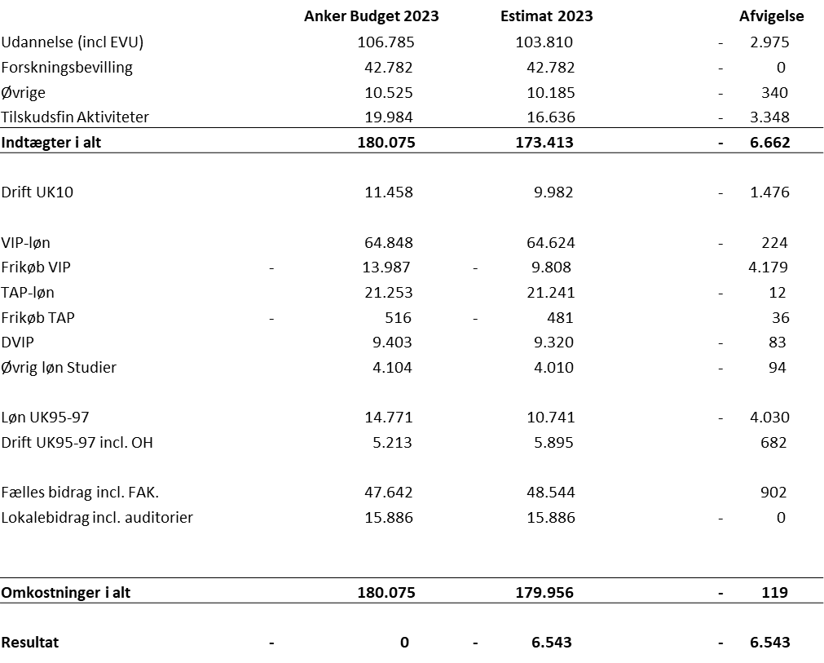

Follow up:

6. Presentation of setup for the accreditation work
Appendix
Explanation: Presentation of the new setup for the accreditation work, aiming for a setup which can operate efficiently across different accreditation forms and institutes. The new setup is approved by the AAUBS management team and consists of:
• AAUBS management group (responsibility: Strategic management)
• Accreditation team (responsibility: Project management and daily operation)
• Accreditation committee (responsibility: Development, daily operation, and anchoring)
• AAUBS council (responsibility: Implementation and evaluation)

Discussion of how the Council will fulfill the new role and ensure implementation of the accreditation work at the business school.
Notes: The Council took note of the presentation and will in the upcoming meetings look further into the accreditation work and how to fulfill the role as “accreditation ambassador”.
Follow up:

7. INSIGHTS
Explanation: We expect the AAUBS dissemination platform, INSIGHTS, to go live before the Council meeting on May 15th, 2023. We hope all VIP staff will publish at the platform.
Discussion of possible editorial setups for INSIGHTS. If the platform is not live on May 15th, 2023, we will postpone the discussion to the Council meeting in September.
Notes: Status on INSIGHTS is that we are awaiting the IT department to activate the domain, which should happen within the next week.
Every research group must commit to publishing content at the platform using all types of media. As the research groups will be responsible for publishing and reviewing own content at the platform, the Council decided that each group is to discuss and decide on their own editorial setup. The Council mentioned in the meeting different issues to be taking into consideration in the discussion on the editorial setup:
- Content to showcase at the platform and do we publish in Danish and/or English?
- Internal and/or external focus?
- Review? The Council proposes to have a junior researcher being responsible for reviewing and coordinating content at INSIGHTS for each research group for a period of six months at a time e.g. Also, to give the research group secretaries access to the platform, so they can assist in coordinating and publishing content.
- Coordination between research groups?
- Anchoring of the platform. The Council proposes that the communication team will be responsible for design, graphics and SoMe strategy going forward.
Follow up: The research groups are to discuss and decide on the editorial setup and by August 4th, 2023, notify the communication team on the setup.

8. Update from Students representatives and Research Groups
Explanation: Short round table update.
Notes:
Victor: Ongoing dialogue with other student organisations on the bachelor -and master programmes.
Dmitrij and Jonas: Dmitrij has been busy getting settled in the new role as head of research group for IB. The IB is happy to announce, that they will be hosting a big IB conference in 2026 in Aalborg.
Frederik: The finance group is looking forward to welcoming assistant professor, Mehmet Caglar Kaya, as new member of the finance group on June 1st, 2023, as well as looking forward to hosting the FMA annual conference on June 7th – 9th, 2023.
Jacob: Business as usual in the IKE research group.
Gunnar: Has been busy finalizing the research group strategy paper for the accounting group as well as participating in the EFREG working group (European Financial Reporting Advisory Group) on EU sustainability reporting framework.
Holger: The marketing group has focus on external funding.
Mikael Byrialsen: MaMTEP is looking forward to welcoming PhD student, Simon Fløj Thomsen, as new member of MaMTEP on June 1st, 2023.
Lasse: Is awaiting further info on the structure of the new joint communication unit and tasks going forward.
Follow up:

9. Communication from the meeting
Explanation: What do we need to communicate from the meeting?
Notes: The Council decided on the following communication from the meeting:
Christian Nielsen to give an update on the new joint EVU organization at SSH at the Employee meeting on June 1st, 2023.
Christian Nielsen to give an update on the new joint communication unit at the Employee meeting on June 1st, 2023.
Christian Nielsen to present the new setup for the accreditation work at the Employee meeting on June 1st, 2023.
Follow up:

10. AOB
Explanation: We would like to suggest Jacob Rubæk Holm & Lasse Steen Jensen as moderators for the Council meeting on September 18th, 2023.
Notes: Jacob Rubæk Holm and Lasse Steen Jensen were appointed moderator for the Council meeting om September 18th, 2023.
Jesper Sort asking head of business school on the reason for sending out e-mail from the study management on teaching; we are teaching too much on the master -and bachelor programmes. The e-mail is sent out because the dean has set up a new practice for approval of the new teaching norm catalogue, which takes longer than expected. We have no info on when the new teaching norm catalogue will be approved.
Jacob Rubæk Holm is suggesting having a discussion on the setup between the study board and the study management to make sure that any disagreement between the study board and the study management is being taking care off/discussed formally and not at the coffee machine. He is suggesting the Council could be acting as a mediator between the contending parties in a potential conflict.
Follow up:

