Minutes  Minutes AAUBS Council  Tuesday 29. november 2022  09.30-11.30, Fib 2, 117 | Aalborg University Business School  Fibigerstræde 2  9200 Aalborg Ø

Members: Klik eller tryk her for at skrive deltagere/faste medlemmer. Christian Nielsen (formand), Jacob Rubæk Holm (VIP), Jesper Sort (VIP), Mikael Randrup Byrialsen (VIP), Michael Simonsen (TAP), Lasse Steen Jensen (TAP)
Cancellations: Jonas Eduardsen (VIP), Daniel Bisgaard Kristensen (ESA), Mikkel Christian Rosengreen (ØF)

Observers: Frederik Lundtofte, Svetla Marinova
Cancellations: Michael Dahl, Lorenzo Massa, Niels Dechow, Finn Olesen, Christian Østergaard, Poul Houmann Andersen
Moderator: Mikael Byrialsen
Agenda

1. Approval of Agenda
Explanation: Approval of the agenda for the meeting
Notes: The agenda was approved by the Council
Follow up:

2. Approval of minutes
Appendix 1: Minutes from AAUBS Council meeting on August 16th, 2022
Explanation: Approval of minutes from AAUBS Council meeting on August 16th, 2022
Notes: Minutes of meeting on August 16th, 2022, was approved by the Council.
Follow up:

3. Updates from the head of Business school
Appendix 2: Viden for Verden Målaftale 2023
Appendix 3: Invitation for Business School Conference on December 7th, 2022
Explanation: CHN to give an update on:
- The SSH-agreement “Viden for Verden Målaftale 2023” as part of the AAU strategy Knowledge for the World 2022-2026. Thank you to the Council for reading and sending remarks to the draft agreement. We expect the draft to be approved at the management meeting with the rector's office on November 23^{rd,} 2022.
- AAUBS strategy 2023-2027 and the work of the management team finalizing the AAUBS strategy based on the research group strategies handed in on November 18th, 2022.
- The AACSB accreditation process
- Business School Conference on December 7th, 2022.
- The Research Evaluation 2023 which was discussed on the Head of Research Group meeting on November 18th, 2022. Between 2017 and 2018, we commissioned an external expert panel to conduct a research evaluation at the research group level covering 2012–2016. The research evaluation runs in a five-year cycle and will be repeated in 2023.
Follow up: Christian Nielsen provided an update on the SSH-agreement “Viden for Verden Målaftale 2023” which was approved at the management meeting with rector’s office on November 23rd, 2022, with the following 3 prioritized targets:
• EVU – AAU Executive is collaborating with other departments on the development of new courses.

• Mission-driven research – We will know on November 30^{th,} 2022, whether Society 5.0 will be part of the mission orientation.

• AAU as a hotspot for talent (VIP and TAP) – We aim for AAUBS to be the best place to start, build and develop your career.

Christian Nielsen also provided an update on the work on the AAUBS strategy; the management group is writing the strategy based on input from the research groups. The key elements of the strategy will be presented at the Business School Conference on December 7th, 2022, in the morning, where we will have an internal seminar. The conference is held in AAU INNOVATE.
As part of the strategy work, input from the research groups will be written into a research group strategy document, which is to be included as documentation for the research group evaluation. The research group evaluation is expected to take place in spring 2023.

Also, OKR, funding and VBN/publication data will be added to the research group strategy document for each research group. The management team will assist the research groups in filling in the document and OKR (specify objectives and how to measure).

The Council took note of the update.

4. Budget and numbers from the Dean
Explanation: CHN will present the 2023-budget as well as the plan for open positions in 2023 (stillingsplan)
Notes: The Council took note of the 2023-budget with the following points of attention:
Budget:
- The rising energy prices are currently financed by AAU.
- We hope for an improvement of the 2023-enrollment numbers compared to 2022.
- We must increase our focus on funding as well as broaden the group of people working with funding.
- We must increase our focus on marketing of our Bachelor -and Master programmes as well as asking everyone to help sharing postings on LinkedIn etc.

Open positions:
- Position as Associate professor in Economics will be announced.

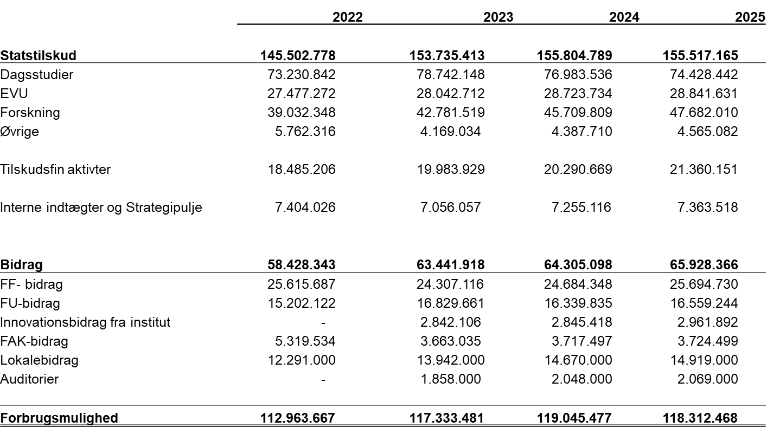

Follow up:

5. Journal of Business

Explanation: Lasse Steen Jensen will present the Journal of Business platform, which is expected to go live on December 7th, 2022. The Journal of Business is a platform like the Harvard Business Review for dissemination from the research groups. The platform will contain both traditional practice-oriented articles, podcasts, webcasts and case studies
Notes: Lasse Steen Jensen presented the Journal of Business platform which is to be the new AAUBS dissemination platform for publishing popular science, short articles, podcasts, and videos, targeted towards business partners. The platform is a tag-based platform meaning that
- All content is organised through predefined, common denominators in a non-hierarchical structure.
- Content is joined together by a common keyword (tag). Tags work like structural and searchable keywords
- You can follow a tag from an article to deep dive further into the database

Lasse Steen Jensen informing the Councill that we are looking for a name for the platform as well as format of the platform (research magazine, review, magazine?). A naming competition will be announced at the Business School Conference on December 7th, 2022, for everyone to join.
The Council took note of the presentation, looking forward to seeing the platform go live.
Follow up:

6. Meeting schedule in 2023
Explanation: The AAUBS Council is to decide on the meeting schedule in 2023. We propose the following dates in 2023 for the AAUBS Council meetings:
- February 27th, 2023
- May 15^{th,} 2023
- September 18th, 2023
- November 27th, 2023
Notes: The Council decided to go ahead with the suggested dates in 2023.
Follow up: Malene Kjerulf Christensen will send out invites for the meetings in 2023.

7. Update from Students representatives and Research Groups
Explanation: Short round table update.
Notes: No notes.
Follow up:

8. Communication from the meeting
Explanation: What do we need to communicate from the meeting?
Notes: The Council decided that CHN is to present the 2023-budget and Journal of Business at the Employee meeting on December 7th, 2022.
Follow up:

9. AOB
Notes: No Notes.
Follow up:

